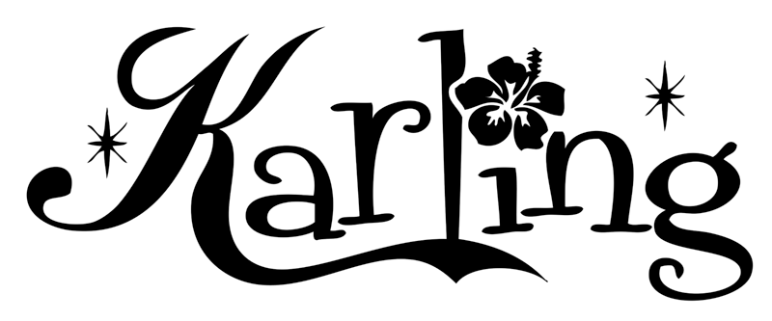
Press Quotes & Awards…
Honored at the 16th Annual Los Angeles Music Awards, winning: “Americana Vocalist Of The Year, Rockabilly Artist Of The Year, Rockabilly Album Of The Year.”
Karling Abbeygate original, “What Another Lovely Day” Nominated Americana Song Of The Year at the red-carpet Hollywood Music In Media Awards.
"...Without fail, on every track Abbeygate's sexy, unassuming charm rubs up against her dreamy voice to effortlessly transport the listener to days long gone. It’s nothing if not ironic that it took a young lady of English descent to create one of the most authentic, American country albums of the year."
HARP MAGAZINE
“...See that blur in the background? That’s all the fun people dancing!”
Editor’s Pick Of The Month
OXFORD AMERICAN
“...Here’s a surprising gem of an album of nostalgic sounding country tunes, only sung by a Silver Lake diva from the UK. Sounds odd, but it’s true, and this lass can sing her heart out.”
MUSIC CONNECTION
“...Not since Bjork dropped the Sugar cubes have I heard a record so sweetly strange.”
ALTERNATIVE PRESS
“...You better fall in love with sexy, Patsy Cline-sounding, old-school country sensation Karling Abbeygate right now!”
BIZARRE MAGAZINE
"...If you haven't seen Karling Abbeygate then you're missing out!"
MTV.COM
"Las Vegas Artist Of The Year."
LAS VEGAS CITY LIFE MAGAZINE (Front cover feature)
“Karling Abbeyate has taken the classic Country Western sound and blended it with today’s sensibilities, and in the process created something quite new and utterly stunning.”
The late FRANKIE LAINE (Rawhide, High Noon)
“...Musician Karling Abbeygate and her band are a mesmerizing talent whose stage presence wraps up the listener in a tightly woven tapestry of nostalgia and fun. This charming British songstress has captivated the imagination of many an audience."
STATESMAN JOURNAL
"...With a vocal style inspired by Cline, a timbre like a higher-voiced Wanda Jackson, and a persona (on record at least) 50% Loretta Lynn, 40% Betty Boop and 10% Emily the Strange, Abbeygate may have just enough sly punkitude to popularize this anachronistic sound, which extends to the clean but deliciously old-fashioned arrangements."
BLOGCRITICS.ORG
"...Equal parts Wanda Jackson, Patsy Cline and Brenda Lee, Karling Abbeygate's new solo album is so firmly steeped in the classic country sounds of the 1950s you'd almost rather listen to it on a big old floor-sized tube-powered radio than your CD player. And yet, it's not gimmicky – what we have here is simply a superb album by a talented singer with a penchant for the classic sounds of the golden age of the Grand Ole Opry and a willingness to bring her own touches to that music."
TURBULA MUSIC
"...Abbeygate is cleaning up on winning awards out west with very good reason this girl rocks, and we mean that in a country way. With a killer command of country and rockabilly at her fingertips, Abbeygate delivers a riveting performance that keeps you hanging on just to see what’s coming next. High octane, high energy and a winner throughout, this is a contemporary country date, with a subtle load of mixmastering thrown in, that you simply shouldn’t miss. Hot stuff."
MIDWEST RECORD MAGAZINE
"...Adorable gal who brings back the days of Patsy Cline and crackling AM radio with 12 songs in all. Half being obscure covers and the other are Karling originals. She IS an original."
DAGGER
"...Abbeygate’s originals--the best of which are “Tonight Is Gonna Last” and “Someone Else’s Man” are so solidly rooted in the grand old country tradition that it’s clear this won’t be a one-off album. Whatever you do, though, don’t let Abbeygate within a hundred miles of Nashville; her sound is nothing like the country music of today, and it’ll be nothing short of a sin if it gets tainted."
BULLZ-EYE
"...I ran into Karling Abbeygate’s voice by chance while browsing artists on MySpace a few months ago. Initially, before listening to the tunes themselves, I was just taken with her excellent cowgirl boots. Mighty fine shit-kickers, but as it turned out, even better music. A modern day hybrid of Patsy Cline and Brenda Lee, Abbeygate croons in the style of the best 1950'5 Country & Western. Press play and time travel back 50 years."
AN AQUARIUM DRUNKARD

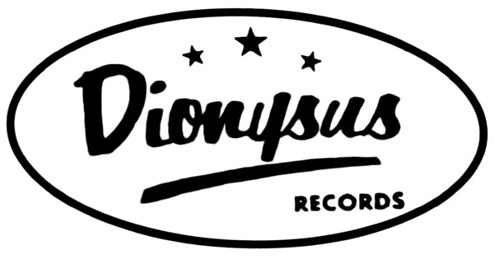

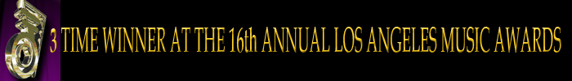

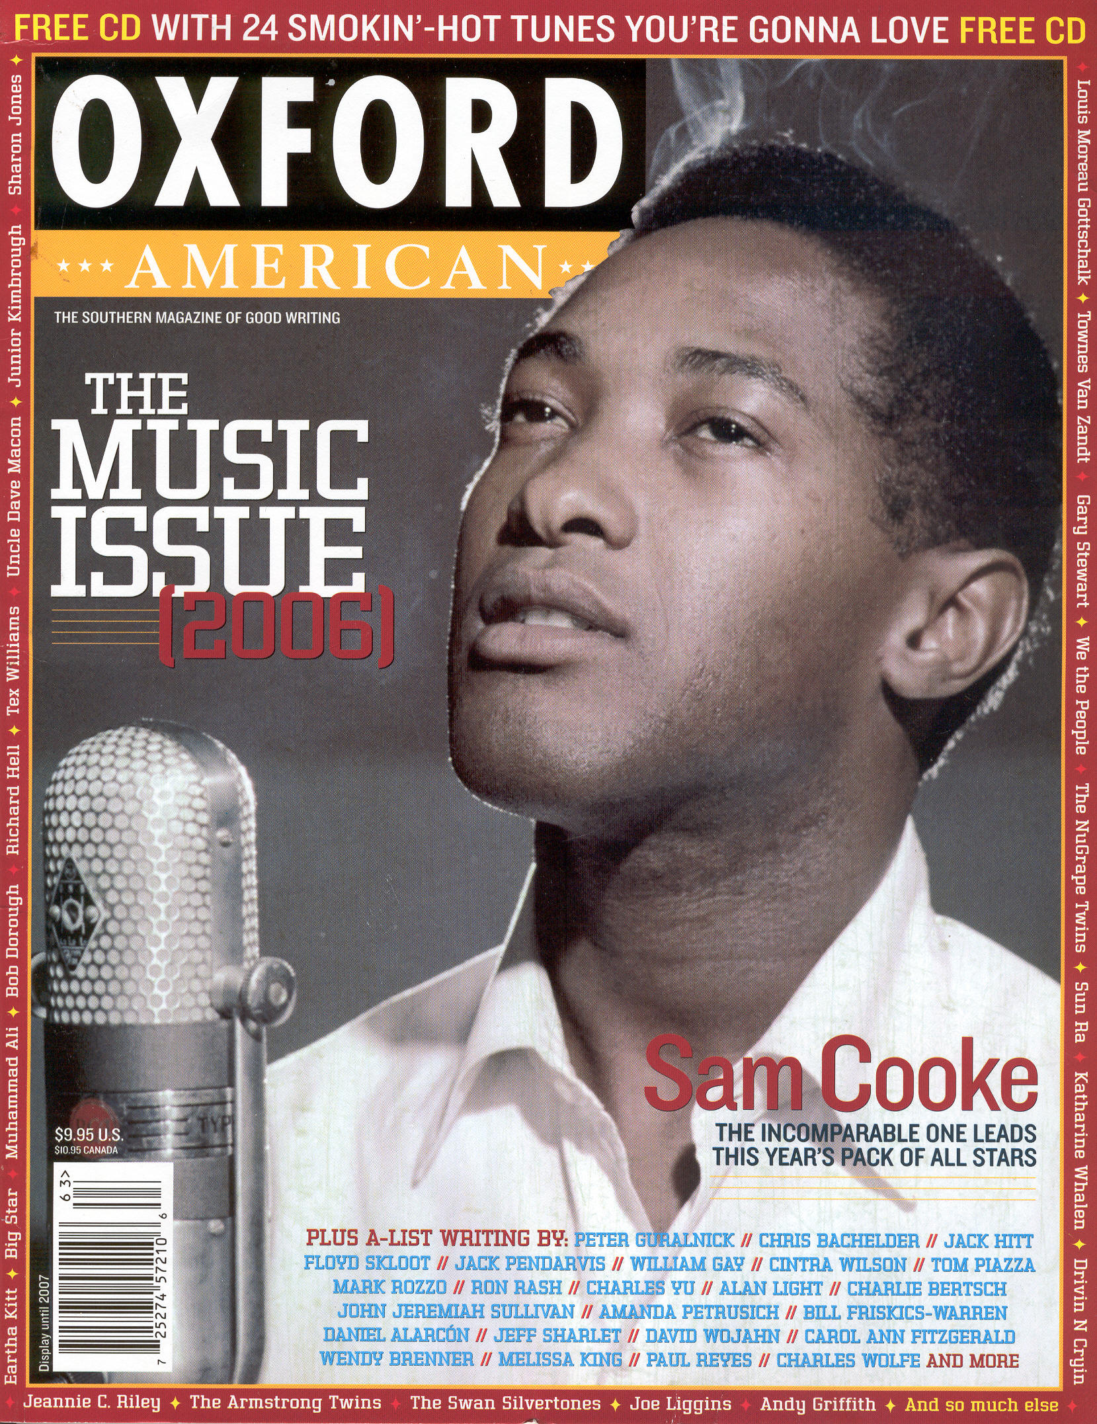


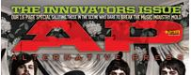
Email: wt_records@yahoo.com www.karlingmusic.com
Booking contact: Donnie Whitbeck (323) 275.1460 V
Karling Abbeygate’s “What Another Lovely Day” nominated for Best Song in the Americana/Roots category.
Karling Abbeygate’s “What Another Lovely Day” nominated for Best Song in the Americana/Roots category.
Karling Abbeygate’s “What Another Lovely Day” nominated for Best Song in the Americana/Roots category.
Karling Abbeygate’s “What Another Lovely Day” nominated for Best Song in the Americana/Roots category.
Karling Abbeygate’s “What Another Lovely Day” nominated for Best Song in the Americana/Roots category.
"Karling Abbeygate has created a sound of ethereal proportions. Ms.Abbeygate's voice evokes an incredible force. It is pure, crystal clear, and powerful. On stage her presence is amazing. The beauty of her voice leaks into bones and cracks and every known joint in the body."
“...See that blur in the background? That’s all the fun people dancing!”
Editor’s Pick Of The Month
“Musician Karling Abbeygate and her band are a mesmerizing talent whose stage presence wraps up the listener in a tightly woven tapestry of nostalgia and fun. This charming British songstress has captivated the imagination of many an audience."
Voted
“Las Vegas Best New Artist Of The Year.”
Karling Abbeygate’s “What Another Lovely Day” nominated for Best Song in the Americana/Roots category.
“Not since Bjork dropped the Sugar cubes have I heard a record so sweetly strange.”
Booking contact: Donnie Whitbeck (323) 468.9738 5546 Melrose Avenue. Los Angeles, CA 90038. USA Email: wt_records@yahoo.com More info on Karling: www.karlingmusic.com
Booking contact: Donnie Whitbeck (323) 468.9738 5546 Melrose Avenue. Los Angeles, CA 90038. USA Email: wt_records@yahoo.com More info on Karling: www.karlingmusic.com

